|  |  |  |
| --- | --- | --- |
|  | **JSPM’s**  **RAJARSHI SHAHU COLLEGE OF ENGINEERING**  **TATHAWADE, PUNE-33**  **(An Autonomous Institute Affiliated to SavitribaiPhule Pune University,Pune)** |  |

**Department of Information Technology**

**Innovation by Faculties in Teaching Learning**

**Name of the Course:** Artificial Intelligence

**Name of the Faculty:** Prof. R.T.Umbare

**Name of the Innovative Method used:** Virtual Lab

**Name of the topic:** A* Search

**Statement of Clear Goal:** The goal of this virtual lab is to provide a clear, interactive, and practical platform for understanding and implementing the A* (A-star) Search Algorithm, a widely used informed search strategy in Artificial Intelligence. The objective is to enable students and professionals to visualize the step-by-step working of the A* algorithm, understand the role of cost functions (g and h values), and observe how optimal paths are computed in different problem scenarios.

**Significance of result:** Through the virtual lab, learners can visualize how A* evaluates nodes, updates cost functions, and determines the most efficient path toward the goal. This hands-on approach bridges theoretical understanding with practical application, reinforcing key AI concepts such as heuristic design, search strategy comparison, and optimal path selection.

In a simulated environment, students gain deeper insights into how informed search strategies outperform uninformed methods and learn to fine-tune heuristics for different problem domains. This experience enhances their analytical and problem-solving skills, preparing them for real-world applications such as robot navigation, route planning, and intelligent system design.

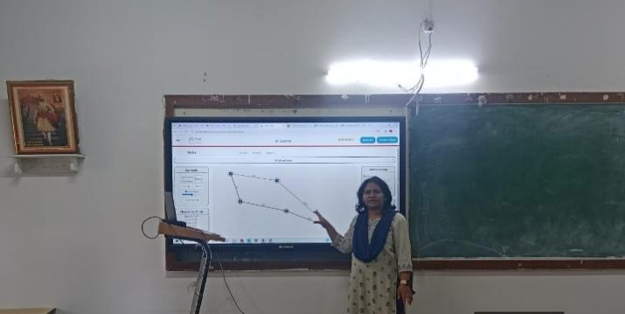

**Name of the Course:** Artificial Intelligence

**Name of the Faculty:** Prof. R.T.Umbare

**Name of the Innovative Method used:** Virtual Lab

**Name of the topic:** DFS

**Statement of Clear Goal:** The goal of this virtual lab is to provide an interactive and practical platform for learning and implementing the Depth-First Search (DFS) algorithm, a fundamental uninformed search strategy used in Artificial Intelligence and Graph Theory. Through this lab, learners will gain hands-on experience in systematically exploring nodes of a graph or tree structure by traversing as deep as possible before backtracking. The objective is to help students and professionals understand the working mechanism of DFS, including its use of stack-based traversal, recursive implementation, and path exploration techniques. By performing this experiment, learners will develop the ability to trace search paths, identify visited and unvisited nodes, and analyze how DFS can be applied to problem domains such as maze solving, network analysis, and puzzlesearch problems.

**Significance of result:** Through the virtual lab, learners can visualize how DFS progresses through different paths, performs backtracking, and ensures complete exploration of the search space. This simulation bridges theoretical learning with practical experience, In a virtual environment, these experiments allow learners to test the algorithm on varied data structures and observe its behavior under different conditions. This not only strengthens their analytical and logical reasoning skills but also prepares them for real-world applications such as pathfinding, scheduling, game development, and network exploration.

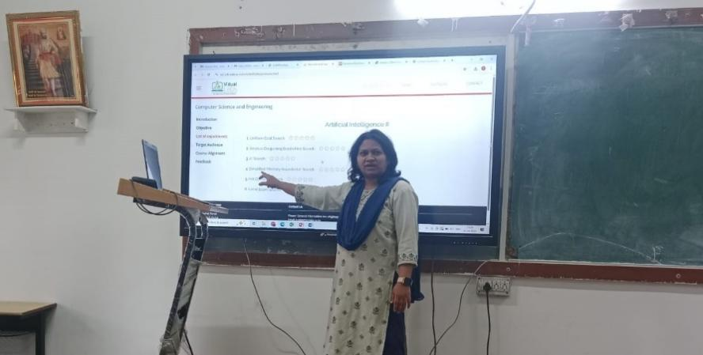

**B. Availability of work related to Innovation by Faculty in Teaching and Learning is on Institute website.**

**<https://www.jspmrscoe.edu.in/information-technology/innovation-practices>**

1. **Availability of work for peer review and critique.**

**[https://github.com/jspmIt/R](https://github.com/jspmIt/JDM)TU**

**D: Reproducibility and Reusability by other scholars for further development**

* **Views**, **likes**, **comments**, and **shares: P**eople are engaging with and potentially applying the content.
* Students are forwarding these contents to other for watching
* Students are giving Comments
* Viewers are thinking critically and considering extensions

|  |  |  |  |
| --- | --- | --- | --- |
| **Sr.No** | **Innovation Used by** | **Details of User** | **Purpose of**  **Reproducibility and Reusability** |
| 1. | Virtual Lab | Prof. Rupali T. Mahajan | To allow viewers to **repeat the process or concept** shown in the video and obtain the same results.  To. Encourage knowledge sharing and collaboration. |

**Course Co-ordinator Module Co-ordinator HOD**

Prof. Juilee D. Mahajan Dr. S.M. Chaware Dr. Nihar M. Ranjan